PAPER EVALUATION USING ARTIFICIAL INTELLIGENCE (HYBRID AI FRAMEWORK FOR RESEARCH PAPER EVALUATION AND REVIEWER RECOMMENDATION)
Scope and Limitations
Department of Computer Science and Engineering, TKR College of Engineering & Technology
Batch C8 (CSE-C) · Academic year [ACADEMIC YEAR]
Table 1: Project team
S.No. | Student name | Roll number
1 | Mula Sreebindu | 23K91A05G3
2 | Puramshetty Vishnu Vardhan | 23K91A05K2
3 | K Sampoorna | 24K95A0512
4 | Korsa Shivashankar | 24K95A0515

Project guide: M Anupama
Chapter and section numbers quoted in the text (for example Chapter 8 or Section 6.2) refer to the full project report, 17.Final Document. Figures and tables in this document are numbered from 1.

1. SCOPE
The scope is what the delivered system does and was tested to do. Each in-scope item exists in the code base and is covered by the evidence named in the last column.
Table 2: In scope
Capability | Detail | Evidence
PDF intake | PDF files up to 20 MB; extension, content type, empty-file and %PDF header checks | Smoke test: non-PDF and fake PDF rejected (400)
Extraction | Page text, normalisation, title heuristic, nine section types, reference parsing | Four real PDFs, test_pdf_extraction
Structural signals | Structure, evidence, method clarity and presentation combined into one score | test_features; Chapter 8 real-paper table
Decision signal | Three-class TF-IDF and logistic-regression model with probabilities | Accuracy 0.55 on synthetic data (limits stated)
Review | Deterministic review always; three-step Qwen2.5-1.5B critique when it loads | Stage timing; about 509 s on a CPU
Literature grounding | Six OpenAlex works ranked by similarity, 8 s timeout, visible failure status | Three live queries, one failure case
Reviewer matching | Embedding, keyword, method, availability and conflict terms; filters; breakdown | Top-1 95.0% on 40 probes
Reviewer directory | Create, update, delete, activate, CSV import and export, conflict terms, load | test_reviewer_crud; smoke test
History and export | Stored analyses; JSON and PDF export | Smoke test export checks
Interface | Landing page, dashboard, analysis, directory, model performance, history, saved analysis, about | Seventeen real screen captures

1.1 Out of scope
• Judging scientific correctness or novelty. The assessment reports structure and evidence; it does not verify claims, and the novelty value of the coverage chart is a fixed placeholder.
• Predicting real review outcomes. The decision signal comes from synthetic data and is a demonstration of the pipeline only.
• Global assignment. No optimiser balances load across a whole conference, and there is no bidding or reviewer self-selection.
• Harvesting publication records. Reviewer expertise comes from a free-text profile and publication titles typed or imported by the editor; there is no h-index, citation count or database harvesting.
• Accounts, roles and multi-user operation. There is no login; the interface and the API are open on the local machine.
• Scanned documents, other languages and other file types. Only English-language PDFs with a text layer are analysed.
• Cloud hosting and mobile clients. The application runs on one personal computer.

1.2 Users, inputs and outputs
Table 3: Users, inputs and outputs
Item | Description
Editor or programme chair | Uploads a submission, reads the assessment and the ranked list, exports the report
Reviewer-directory administrator | Maintains the profiles, conflict terms and loads (the same person in practice; there are no separate accounts)
Input | A research-paper PDF, optional filters (active only, minimum score, topic, method), reviewer profiles typed or imported as CSV
Output | On screen: structural score, decision signal, review, literature, ranked reviewers with audit breakdown. Files: JSON and PDF report
External services | OpenAlex (title and keyword text only); Hugging Face for the first download of models

2. ASSUMPTIONS
The results hold under these assumptions; where one fails, the quality of the output is expected to fall.
• English-language papers with a text layer. The extraction reads the PDF text; scanned pages without a text layer give almost nothing, and the interface warns when fewer than 50 words are found.
• Conventional section headings. Section detection matches headings such as Introduction, Methodology or Conclusion on short lines; roman-numeral headings are not recognised.
• A maintained reviewer directory. Matching quality depends on the profile text, topics, methods and conflict terms filled in by the editor; the demo profiles are placeholders.
• Conflict terms are written the way they appear in papers. Detection compares literal strings, so affiliations and names must be entered in the form used in manuscripts.
• One trusted user at a time on a local machine. No authentication, open cross-origin access and a single SQLite file are acceptable only in that setting.
• An editor reads the output as advice. The assessment and the ranking are decision support; the final judgement stays with a qualified human.
• Internet access is occasional. It is needed for the first model download and for OpenAlex; without it the literature step reports unavailable and the rest continues.
• A modern PC. Windows, Python 3.11, Node.js 18 or newer and about 6 GB of free memory for the local language model. Timings are for the measured 12th Gen Intel(R) Core(TM) i5-12500 with 15.7 GB of memory and no GPU.
• The synthetic decision data are understood as such. The decision signal is read as a demonstration; its confidence is not a probability of acceptance.

3. LIMITATIONS
The limitations below are real and affect how the system should be used. Each is listed with its effect and with what could reduce it.
Table 4: Limitations
No. | Limitation | Effect | What would help
L1 | Decision model trained on 1,400 synthetic, template-generated rows; the public PeerRead probe returned no data | Accuracy 0.55 is close to the ceiling of about 0.56 set by the labelling; borderline recall 7%; all four real papers were labelled borderline (confidence 0.55-0.66); not evidence of predicting real decisions | Train on real review data (PeerRead, OpenReview) with decisions
L2 | Reviewer pool of 6 demo profiles; no publication histories, no h-index | Ranking quality on a real committee is unknown; the abstract's h-index and history ranking is not implemented | Import real profiles and publication lists
L3 | Matching evaluated on 40 abstracts written by the team with the team's labels | Top-1 95.0% (embeddings) and 75.0% (fall-back) are optimistic and not comparable with the base paper | Independent expert labels on real submissions
L4 | TF-IDF fall-back fitted once on the first request and then frozen | Offline matching is weaker (top-1 75.0% against 95.0%) and depends on which paper came first | Fit on the reviewer profiles or ship a fixed vocabulary
L5 | Novelty is not assessed; the coverage chart shows a fixed Novelty value of 55 | The review cannot say how original a paper is; OpenAlex results are context, not a novelty test | A citation- or embedding-based novelty measure
L6 | Structural weights (0.35, 0.25, 0.25, 0.15) and thresholds are unfitted heuristics; section detection is regex based | Roman-numeral headings missed (the IEEE base paper: no introduction, title returned as the DOI line); words such as model or approach can mark a methodology heading | Fit weights on human ratings; layout-aware parsing
L7 | Conflict detection is literal string matching on the first 3,000 characters | 12 of 12 literal links found, 0 of 3 paraphrased links found, 0 false flags on 240 clean pairs; co-authorship is not checked | Co-authorship and affiliation graphs; fuzzy matching
L8 | Local Qwen2.5-1.5B on a CPU at about three tokens per second; output not fact-checked | About 509 s for the review step; the synthesis of a real paper contained wrong statements; hidden text in a PDF could steer it [2, 27] | Quantised or GPU model, claim checking, injection filter
L9 | Every reviewer profile is re-embedded on every request | Ranking takes 86 ms for 6 reviewers and 5.2 s for 500 with sentence embeddings | Cache profile embeddings, update on change
L10 | OpenAlex needs internet and the query is not sanitised | A title containing a question mark gives HTTP 400 and the status unavailable (the survey PDF) | Strip punctuation; cache results
L11 | No authentication, open CORS, single user; timestamps stored as UTC and shown without a zone; a corrupt but %PDF-headed file returns 200; a CSV without names imports 0 rows silently | Safe only on one trusted machine; times read about 5.5 hours behind local time | Authentication, zone-aware times, stricter validation
L12 | Items of the batch abstract not implemented: deep-learning area classifier, originality score, readability indices beyond sentence length, scope alignment with a venue | Objectives 2 and 5 are met with simple methods only | See Chapter 10

Two figures illustrate the two limitations that matter most for reading the numbers. The first shows how the synthetic labels are built: the label is drawn from the same strength and weakness phrases that appear in the text, and the borderline class comes from both groups, so accuracy on this data cannot exceed about 0.56. The second shows that conflict detection finds literal links but not paraphrased ones.
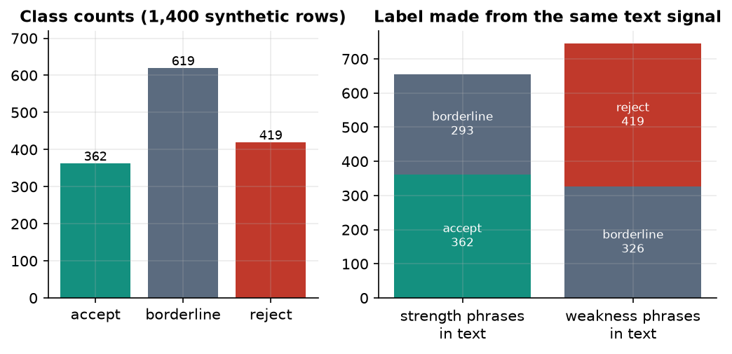
Figure 1: Class counts of the synthetic dataset and how the label relates to the phrases in the text (limitation: synthetic training data).
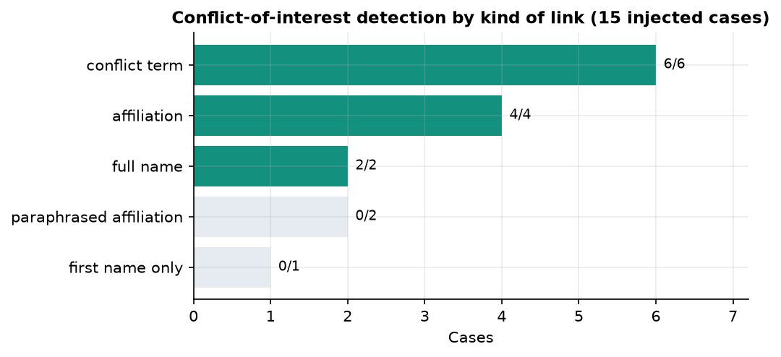
Figure 2: Conflict-of-interest detection by kind of link: literal strings are found, paraphrases are missed.

4. WHAT WAS NOT MEASURED
Honesty about gaps matters more than a longer list of numbers. The following were not measured, and nothing in these documents should be read as a claim about them:
• accuracy of the decision model on real peer-review decisions;
• reviewer-assignment quality against independent expert judgement or against the real assignments of a conference;
• the quality of the language-model critique (no human rated it, and no factual-consistency check was run);
• a user study with editors or reviewers, and the time saved in a real editorial workflow;
• behaviour on scanned PDFs, non-English papers and unusual layouts beyond the four real papers tried;
• performance with a GPU, with a quantised model or under many simultaneous users;
• the effect of tuning the matching weights (the shipped weights were not searched), and the sensitivity of the structural weights;
• robustness to deliberately manipulated PDFs (hidden instructions), although the literature shows it is a risk.
The 40-abstract probe result and the conflict injection test were measured, but both use material written by the team and are optimistic for that reason; they are not used as evidence of real-world accuracy.

